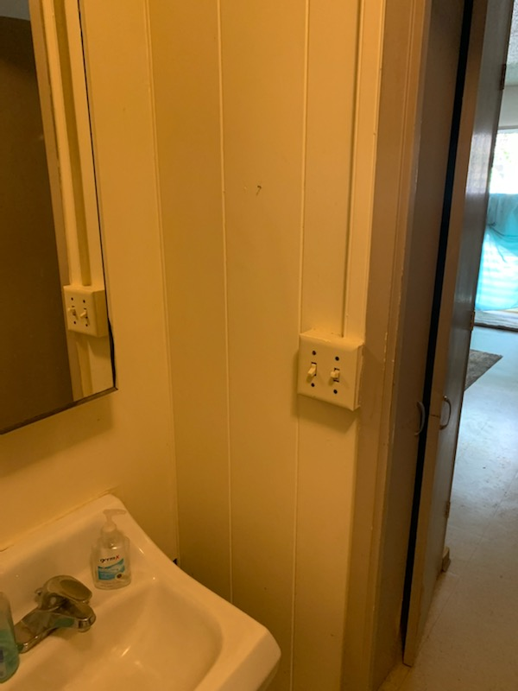
Unit 3L wall
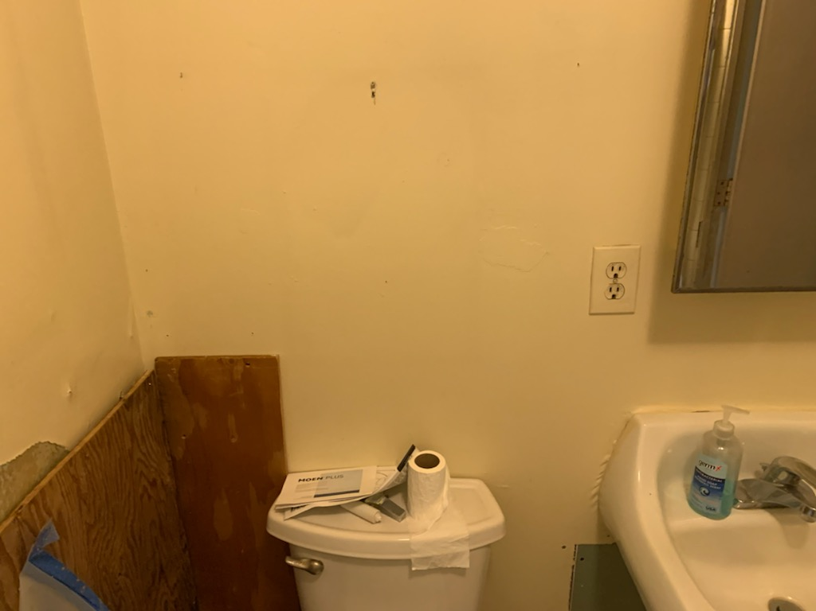
Unit 3L & 3R share a wall both wet and mold.
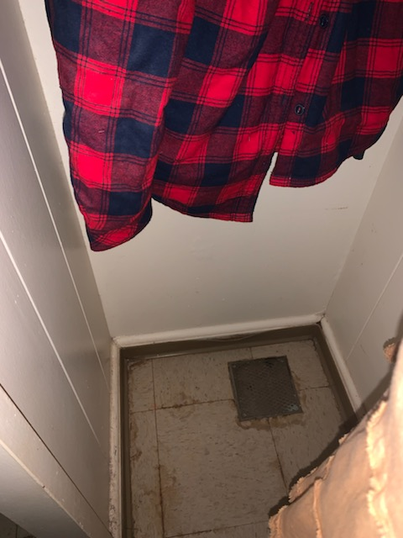
Unit 3R closet wall
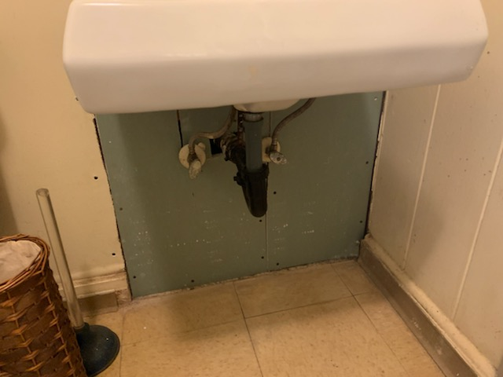
Unit 3L under vanity
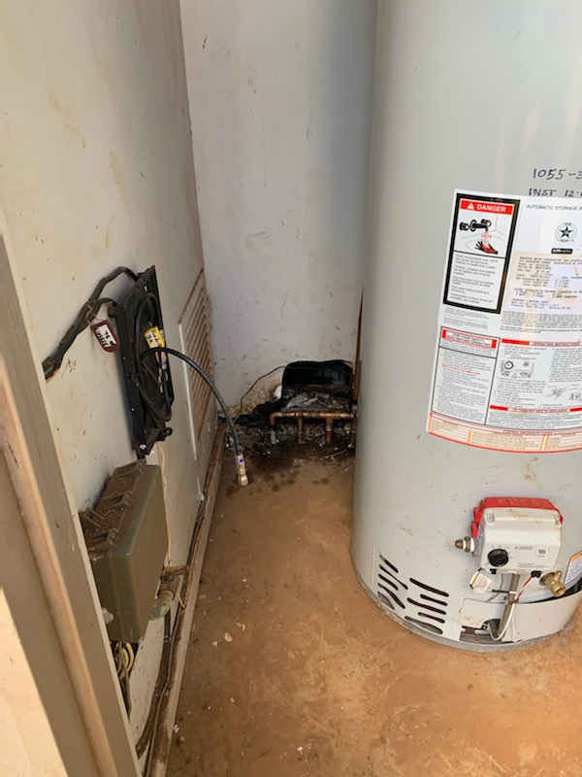
Water heater room where mold penetrated into bathroom wall
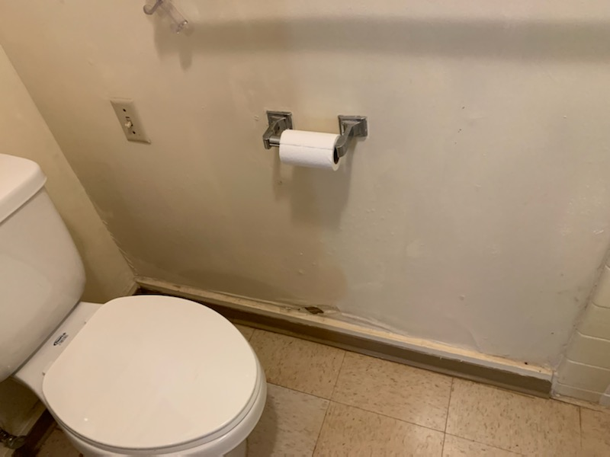
Unit 3L only this wall as the wall behind the toilet was dry
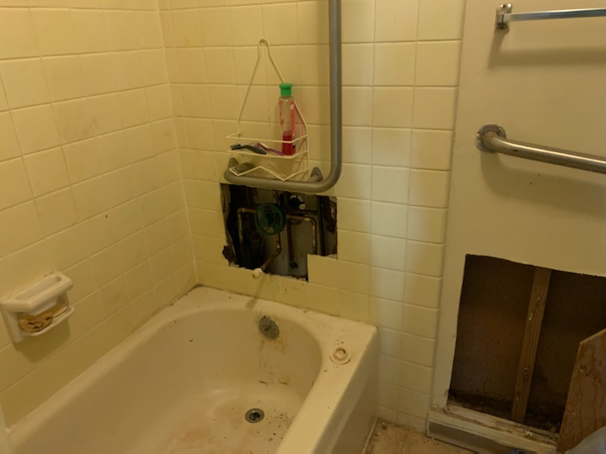
Unit 3L need to replace tile area. Found mold and dripping shower valve.

